
RAJALAKSHMI ENGINEERING COLLEGE
THANDALAM, CHENNAI 602105
CR23532

CYBER AND DIGITAL FORENSICS
MINI PROJECT REPORT
Five Individual Case Study Assignments
Submitted by
NISHANTH ELANGO RAJAN
241901075
Submitted as part of the academic curriculum for the degree of
BACHELOR OF ENGINEERING
in
COMPUTER SCIENCE AND ENGINEERING
(CYBER SECURITY)
ACADEMIC YEAR 2026 - 2027
October 2026
INDEX
S NO | TABLE OF CONTENTS | PAGE NUMBER
1 | Abstract and project overview | 1
2 | Mini project 1 College server investigation | 2
3 | Mini project 2 Linking files to a user account | 7
4 | Mini project 3 Forensic imaging and safekeeping | 12
5 | Mini project 4 Deleted evidence from shadow copies | 17
6 | Mini project 5 Multi source cyber investigation | 22
7 | References | 27

ABSTRACT AND PROJECT OVERVIEW
This report presents five individual investigations aligned with the five case studies in the CR23532 assignment brief. Each project defines a different scenario, sets investigation objectives, explains evidence preservation, and connects proposed examination steps to defensible conclusions. The central result is a repeatable approach: preserve the source, verify the acquisition, correlate independent artifacts, and state the limits of attribution.

Study conventions
All organizations within the scenarios, account labels, device identifiers, artifact records, and incident times are hypothetical. They are analytical examples, not observations from seized devices. The scenarios are distinct within this report; uniqueness against other students' submissions must be checked by the student and faculty.
ILookIX and IXImager workflows describe intended procedures. No acquisition, recovery, password attempt, malware execution, or provider query is claimed. Exact supported formats, hardware, features, and menu names must be checked against the licensed laboratory build. The vendor distinguishes Standard and Advanced editions; IXImager and automatic Volume Shadow Copy processing are listed for Advanced.
Illustrative timelines use India Standard Time, IST, UTC+05:30, unless a raw timestamp is explicitly shown. Source time, encoding, clock error, and conversion are recorded separately. Evidence IDs are local to their mini project. Labels such as H1 denote proposed digest fields, not computed hash values.
In this report, direct evidence means a record that directly documents a narrow event, such as an authenticated service request. Corroborating evidence strengthens a relationship through another source. Contextual evidence describes the environment. These are investigative labels; a recorded account event does not by itself identify the human operator or settle legal admissibility.

Mini project 1 College server investigation

Scenario and objectives
Unique title: After hours copying of an examination moderation bundle using a temporary departmental account.
The fictional examination office reports that ModerationBundle_Oct2026.zip was accessed from server EXAM-SRV01 after staff had left. The bundle contains draft examination material and a moderation register. A Windows workstation, LAB-WS17, and a USB drive left beside it are identified for preservation. The temporary account exam.temp was permitted to assist with moderation during working hours. Investigators must determine whether the bundle was accessed and copied outside that permitted task.
Assumptions: the administrator can authorize collection of institution owned systems; the suspected window is 24 September 2026, 20:00 to 22:00 IST; relevant server auditing was already enabled; both workstation and server use NTFS; and the USB contains a readable file system. These assumptions must be tested. Neither the account holder nor the USB owner is presumed responsible.
The objectives are to identify the session and device involved, establish whether a content equivalent file reached the USB, preserve material for institutional review, and assess alternative explanations such as an approved backup or compromised credentials. The investigation should also determine whether the access exceeded the account's actual authorization, which is a policy and factual question as well as a technical one.

Identification and collection
Identification begins with the signed complaint, the exact file paths, normal access policy, relevant accounts, and the time window. The team records what the administrator personally observed and what was inferred. A scoped authority document identifies devices, accounts, permitted evidence types, dates, and recipients of findings. Immediate preservation requests protect server logs from normal rotation.
Collection starts with photographs, device identifiers, power states, attached media, and the displayed clock compared with a trusted reference. A trained examiner decides whether live collection is needed to preserve volatile sessions or encryption information. Live collection changes the system and must be documented. Powered off devices remain off until an approved acquisition method is chosen.
The server may need to remain operational. Export relevant original log files and administrative records through an authorized account, recording the export method, scope, source, and collection time. These are scoped logical acquisitions, not full server images. Acquire workstation and USB images through suitable write protection, verify them, and keep originals sealed. General forensic process guidance supports preservation and documented examination.

Evidence inventory and preservation
ID and item | Investigative value | Proposed examination and limitation
C1 Signed complaint and access policy | Context and authority | Defines the allegation and permitted task; does not prove a copy occurred.
C2 Server Security EVTX and share audit logs | Direct record of account and object events | Correlate logon identifiers and object paths; coverage depends on preexisting audit settings.
C3 LAB-WS17 storage image | Account and activity corroboration | Inspect profiles, logons, recent files, browser records, and file system artifacts; a profile path is not human identification.
C4 Recovered USB image | Content and destination evidence | Locate the bundle and compare bytes with the server version; possession and timing require separate support.
C5 Original examination bundle and version history | Content reference | Establish which version was confidential and compare hashes; matching names alone are insufficient.
C6 USB device registry and setup records | Device association | Relate serial or volume information to the workstation; a connection does not establish copying.
C7 DHCP and switch records | Network context | Map the source IP to a device during the window; account for leases, reused addresses, and missing records.
C8 Authorized staff roster and approval records | Exculpatory and policy evidence | Test approved after hours work or backup activity; retain evidence that weakens the allegation.

Every collected item receives a case ID, exhibit ID, collector, location, collection timestamp and timezone, description, and custody record. Device images additionally need make, model, serial number, capacity, source interface, image format, tool version, acquisition scope, read errors, and digest results. Exported logs retain their native files and an export manifest; a spreadsheet used for analysis remains a derivative.
Collection precautions include testing the write blocker on non-evidence media, checking source and destination identities, preventing automount, and disabling any laboratory process that could quarantine or rewrite the evidence. Use controlled forensic storage, restricted access, and separate master and working images. Malicious executables are not opened on the examiner's ordinary workstation.
Store the USB separately in suitable protective packaging. Seal identifiers and device photographs should match the custody record. Record each transfer with actual names, purpose, condition, signatures, and times. Hash image copies and report attachments after creation and transfer. A hash supports byte integrity over a defined interval; it cannot establish truthful content, ownership, or lawful collection.

Investigation flowchart
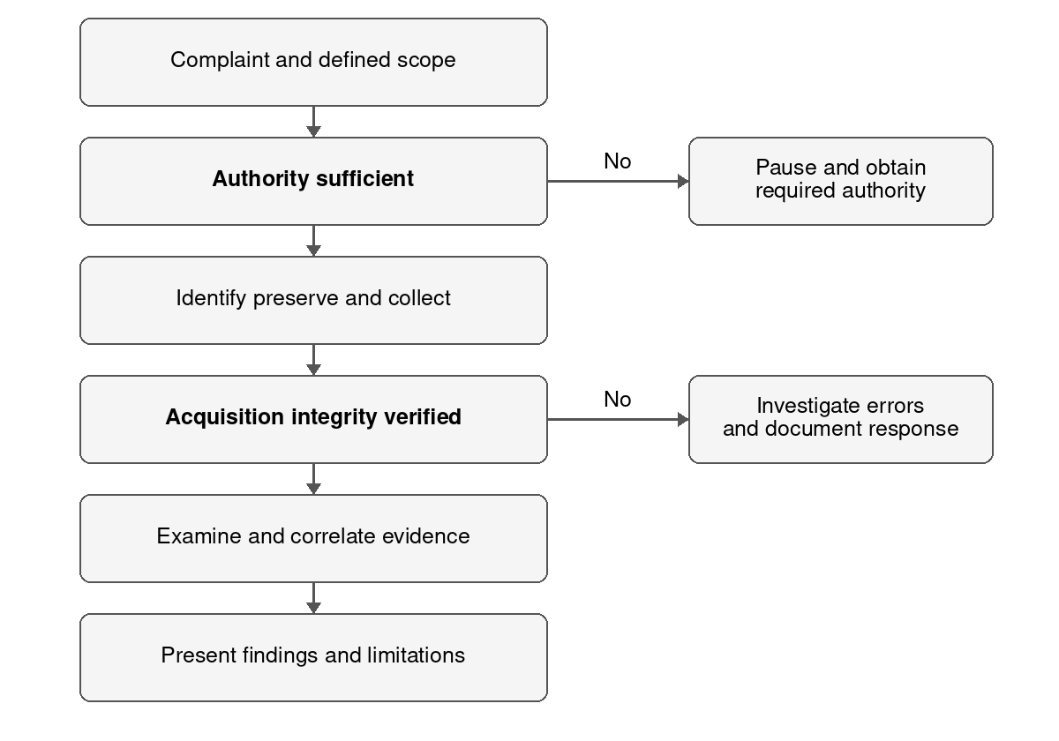
Figure 1 Proposed sequence from complaint to findings

Examination analysis and presentation
Examination extracts relevant records from verified working copies. The examiner searches the exact bundle name and path, identifies account security identifiers, extracts pertinent server events, and reviews USB association artifacts. Each result is linked to its source image or log, record identifier, parser version, and any export hash.
Analysis joins the server session to the workstation and the USB content. The examiner tests whether logon, audited reading, local staging, USB attachment, and matching content form a consistent sequence. A shared network address or profile name alone is insufficient. Both incriminating and exculpatory observations remain in the case notes.
Presentation states what the records support, how they were obtained, and what remains uncertain. Technical exhibits accompany a plain language summary. The reviewer should be able to trace each conclusion to an exhibit and distinguish a recorded event from an inference.
Decision points in the flowchart are deliberate. Lack of authority pauses collection; integrity failure prevents reliance on that acquisition until investigated. A justified repeat acquisition is recorded as a new attempt rather than silently replacing the first image or its error log.

Timeline reconstruction
The timeline below is hypothetical. All values are normalized to IST for display. The workstation clock is assumed to have been 90 seconds fast; server time is assumed accurate to within two seconds. In real examination, these offsets must be supported by clock comparison, synchronization history, or another reliable reference.
Normalized time on 24 September | Example artifact | Interpretation and limit
20:37:12 | C3 interactive logon for exam.temp | Account session begins on LAB-WS17; human operator remains unknown.
20:41:03 | C2 network logon from 10.20.4.17 | Server accepts an account session; DHCP records must establish device mapping.
20:42:16 | C2 audited ReadData for bundle path | Recorded access right was used if auditing captured it; it is not a copy destination record.
20:44 to 20:46 | C3 local staged bundle and journal changes | Consistent with creation of a local copy; timestamp behavior requires context.
20:47:08 | C6 USB association record | Device connection is consistent with the transfer window; artifacts may describe first or last connection differently.
20:49 to 20:52 | C4 bundle on USB matching C5 bytes | Strong support for content duplication if verified; USB time alone cannot identify the copying actor.
21:03:20 | C3 session termination record | Session ends; missing termination records would not prove it continued indefinitely.

Preserve raw timestamp values before converting. An EVTX SystemTime stored as UTC should be interpreted as UTC even when a viewer displays local time. For example, 15:12:16Z corresponds to 20:42:16 IST. A workstation local display of 20:38:42 with a proven 90 second fast clock corresponds to 20:37:12 IST. Do not apply that offset automatically to server or USB timestamps.
For each event, retain the time field's meaning, resolution, conversion, estimated error, source ID, and confidence. The original offset is part of the evidence; normalization is an analytical layer. Date-only or low-resolution timestamps should become intervals rather than falsely precise points.
Windows event 4624 records successful logon. Event 4663 can record use of an access right on an audited object; its Logon ID can support correlation [R8, R9]. Inspect logon type, account SID, source information, object name, access mask, and record ID. Do not assume either event exists unless the audit configuration and retention support it.
To test the copying hypothesis, compare the server bundle with the USB bundle, examine whether backups or scheduled jobs created either copy, and look for remote sessions or malware activity. The combined example records support transfer of the bundle through the workstation, but they do not exclude another person using exam.temp. Exact file equality does not alone establish the direction or time of copying.

Sample forensic report structure
Report section | Required content
Case identification | Case number, examiner, requester, dates, scope, authority, and questions.
Evidence received | Exhibits, devices, native exports, seal condition, custody references, and acquisition details.
Methods | Tool builds, validated procedures, write protection, hashes, filters, offsets, and error handling.
Findings | Source cited observations, relevant events, file comparisons, and an evidence timeline.
Interpretation | Reasoning connecting the exhibits, alternative explanations, and confidence boundaries.
Conclusion | Answers to the investigation questions, unresolved attribution, and further evidence needed.
Appendices | Full custody forms, acquisition logs, digest manifests, record exports, and genuine screenshots if obtained.

Findings for a non technical authority
An appropriate illustrative summary is: The example records show that the temporary examination account accessed the moderation bundle from a departmental workstation after hours. A content equivalent bundle is present on the recovered USB. The timing and device associations support a copying sequence through that workstation. The records do not establish who physically operated the account, whether credentials were shared, or whether an exceptional approval existed.
Explain a hash as a check for matching byte sequences. Present a short timeline with a source for each claim. Avoid guilt declarations, unsupported percentages, and unverified automated labels. Mark findings as recorded, inferred, or unresolved.

Legal and ethical considerations
Institutional access is scoped by written authority and policy. Collection of personal devices, private accounts, or unrelated student communications needs separate lawful authority where applicable. The team should minimize irrelevant personal data, limit who sees examination material, protect privileged or sensitive records, and use a documented retention process. Authorized administrators should handle operational containment, while examiners document its effect on evidence.
For an Indian evidentiary submission, the Bharatiya Sakshya Adhiniyam 2023 addresses electronic records in sections 61 to 63, including conditions and certification under section 63 [R7]. The applicable route and certificate should be checked with the responsible legal authority. A matching hash and custody form do not independently satisfy every admissibility requirement. Preserve the responsible custodian's account of how records were generated and exported.

Conclusion and project outcome
The project supplies the flowchart, evidence inventory, preservation procedure, timeline, and report structure. Verified records could establish a technical sequence and account use. Human attribution remains conditional until shared access, approved tasks, and compromise are tested.

Mini project 2 Linking files to a user account

Scenario and investigation question
Unique title: A disguised budget checking utility in one profile on a shared finance desktop.
Three staff accounts use the fictional desktop FIN-PC09: accounts.alpha, accounts.beta, and support.local. A suspicious executable named BudgetCheck.exe appears under the beta profile. A hidden folder contains draft supplier spreadsheets, an encrypted archive named VendorReview.7z is present, and a browser profile contains a possible download record. The question is whether accounts.beta created, downloaded, or executed the relevant files, and how strongly that account activity can be attributed to a person.
Assumptions: FIN-PC09 runs Windows 11 on NTFS; the accounts normally have separate credentials; auditing may be incomplete; the machine is already preserved; and the examiner has authority to inspect the relevant profiles. The executable is treated as suspicious because of its location and reported behavior, not declared malicious solely because of its name. All proposed results remain hypothetical.

System inventory before analysis
Component | Information to document | Forensic reason
Computer hardware | Asset ID, photographs, motherboard, CPU, RAM, interfaces, and power state | Identifies the seized system and acquisition constraints.
Storage hardware | SSD model, serial, capacity, NVMe interface, sector sizes, and health indications | Selects a compatible acquisition path and records possible read limitations.
Other media | Connected USB devices, optical media, external disks, and network shares | Locates additional destinations and independent evidence.
Operating system | Windows edition, build, patch level, installation context, and timezone | Determines relevant artifacts and parser compatibility.
Storage layout | GPT partitions, NTFS volumes, volume IDs, encryption, and recovery partitions | Separates physical device coverage from logical volume analysis.
User environment | Account SIDs, profile paths, group membership, local or domain status | Maps records to accounts without relying on display names.
Applications | Browser versions, archive tools, office tools, sync clients, security software | Identifies possible creators of the relevant artifacts.
Laboratory environment | Tool versions, license edition, parser settings, image formats, and workstation configuration | Supports reproducibility and explains unsupported features.

Collect the inventory through preserved records or documented authorized examination. Do not boot the original merely to fill inventory fields. Unknown values stay unknown until recovered. Hardware identifiers and account records should be distinguished from labels assigned by the investigator.

Storage metadata hidden files and encryption
Physical storage determines acquisition scope and limitations. A device image may preserve addressable partitions, allocated files, unallocated sectors, and file system structures. It does not guarantee recovery of SSD data already affected by TRIM, internal garbage collection, overwritten sectors, or encryption. A logical export usually captures selected accessible files and may omit deleted space or low level metadata.
On NTFS, examine the Master File Table, allocation state, directory relationships, alternate data streams, and relevant USN journal records. Compare multiple timestamp fields without assuming identical meanings. File creation time may represent arrival on that volume, modification time may survive a copy, and last access time may be disabled or delayed. A metadata owner SID can reflect access control inheritance rather than the person who authored the content.
The OS supplies separate context through account databases, registry profile mappings, logon events, and application artifacts. Browser databases may identify a download URL and destination. User specific shortcuts, recent document records, and application histories can place a path in a profile's activity. Correlating these different record types is stronger than using one filename or timestamp.

Handling concealed and protected content
Condition | Intended examination | Handling and interpretation
Hidden or system attributes | Enumerate files from the image, including attribute flags | Concealment is not proof of malicious purpose; ordinary applications use these attributes.
Extension and signature mismatch | Compare filename extension with file header and validated type detection | A renamed executable merits examination; do not execute it on the evidence system.
Alternate data streams | List streams and export relevant content separately | Preserve stream names and parent file linkage; ordinary download zone metadata is also a stream.
Password protected archive | Preserve bytes, identify container type, and record accessible metadata | Seek an authorized password or key source; failed access does not mean the archive is empty.
Encrypted volume or document | Preserve ciphertext and identify the encryption context | Recovery material is sensitive; document any authorized decrypted derivative and its relation to the source.

The hidden attribute can be inspected without toggling it on the original. Encrypted evidence should remain intact while investigators examine surrounding context. Any authorized password recovery is limited by scope, documented, and performed on a copy. A decrypted file receives its own digest and export record; its digest will not equal the ciphertext container digest.
The suspicious utility should be examined first through static properties such as byte signature, hash, embedded strings, signing information, and provenance. A valid signature is context, not assurance that behavior is harmless. Dynamic analysis, if separately required, uses an isolated authorized laboratory and its own observation log.

Evidence linkage matrix
The example matrix distinguishes account level linkage from person level attribution. Dates are hypothetical and normalized to IST on 25 September 2026. F1 denotes the proposed content digest of BudgetCheck.exe; no digest has been calculated.
Artifact and path | Time or account field | Proposed relationship | Evidential strength and limit
B1 Browser download entry for BudgetCheck.exe under beta profile | Download start 14:02; destination C:\Users\beta\Downloads | Browser profile records arrival of the executable | Direct record of a download entry; sync or another user of that profile can explain it.
B2 NTFS entry for the downloaded file | Creation 14:03; parent directory and file record ID | Consistent with arrival at the browser destination | Corroborating file placement; path and owner fields do not prove who created it.
B3 Security 4688 process record if already enabled | 14:06; beta SID, process ID, executable path | Connects a process creation to a security context | Direct account level process evidence; validate full path and compare the file version.
B4 Prefetch record for BudgetCheck.exe if present | Possible execution times and referenced files | Independently supports execution on the machine | Supporting machine activity; generally does not identify the operator.
B5 Hidden folder C:\Users\beta\AppData\Local\BudgetCache | Filesystem attributes; spreadsheet names | Places related files in the same profile tree | Context plus possible file relationships; applications can create folders automatically.
B6 VendorReview.7z in beta Documents | Creation 14:15; archive bytes and format | Possible packaging of supplier files | Container presence is direct; its contents and purpose remain unknown until authorized access.
B7 User specific shortcut or recent document record | Path to spreadsheet and beta hive provenance | Supports access through the beta profile | Corroborating account activity; application updates can be automatic.
B8 Logon events and remote session records | Beta SID; session identifiers; 13:55 to 14:30 | Places download and process events within a session | Direct session context; remote access or credential sharing can weaken person attribution.

Correlate stable identifiers: image ID, account SID, full path, file record, session, and digest where possible. Display names are secondary. The executable may have been replaced after the event; compare F1 with preserved prior versions before linking current bytes to the process record.
The hypothesis is that beta downloaded and started the utility before supplier files appeared nearby. Test all three profiles, services, scheduled tasks, and remote administration records. A task or attacker could trigger a process under beta; account activity does not establish deliberate human conduct.

Intended ILookIX workflow
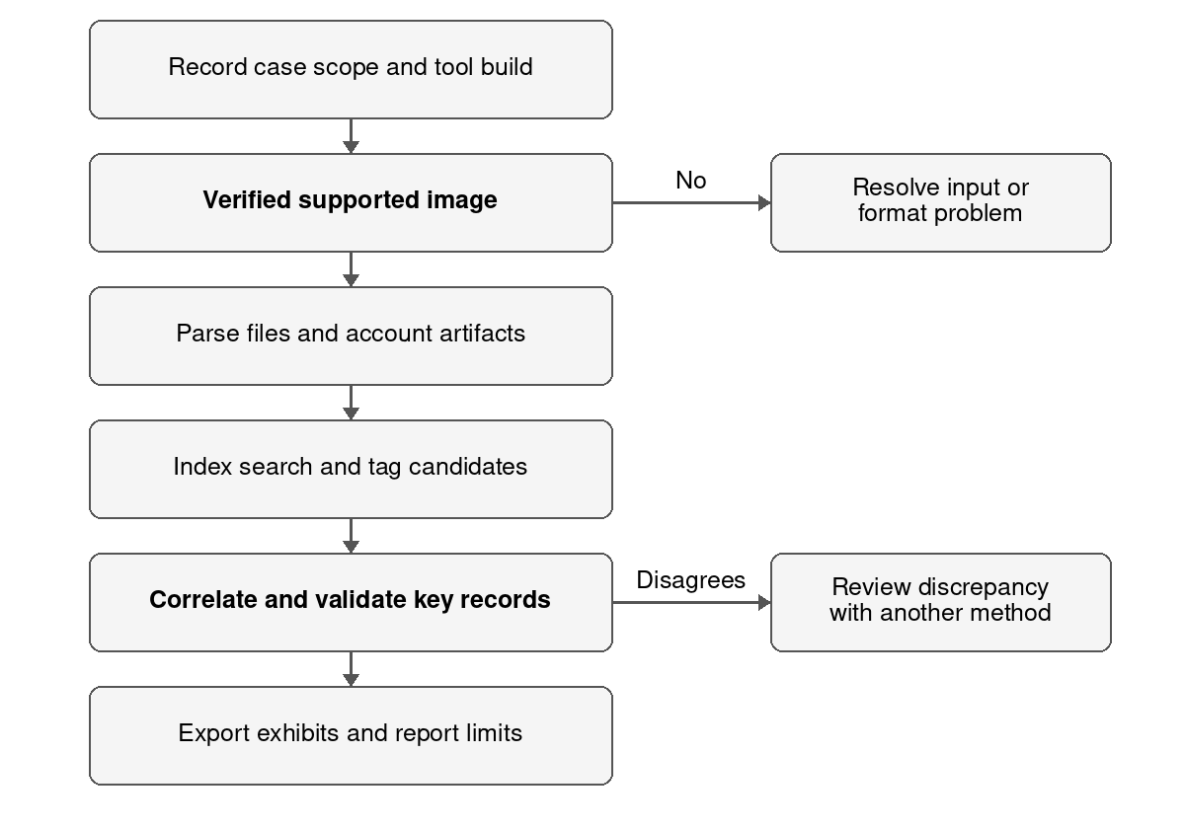
Figure 2 Proposed ILookIX examination with validation gates
Before import, obtain or verify a documented acquisition. When working from original media, use a suitable tested acquisition tool and write protection; importing an image is not an acquisition. Match the image or container's supported format to the licensed ILookIX build and preserve every segment and associated log. The vendor lists registry, email, recovery, searching, and categorization features [R2].
The expected products are a documented case database, a system inventory, tagged source records, extracted files, a linkage matrix, and a report. Processing failures should remain visible. An unsupported artifact type is passed to another validated parser on a working copy, and that parser's output is independently linked back to the source.
The workflow describes intended operations, not exact version dependent menu clicks or a completed examination. Filters and known file exclusions change the working view; they must not delete the preserved master evidence.

Procedure evidence obtained and interpretation
Step | Intended procedure | Expected evidence and interpretation
Case setup | Record authority, case ID, examiner, tool build, timezone, and source manifest | Establishes how the examination can be repeated.
Import and verify | Add the verified supported image; record image hashes and processing logs | Confirms input identity; matching hashes do not prove every parser is correct.
Parse and categorize | Enumerate partitions, files, registry stores, archives, and browser data where supported | Produces searchable records; check deconstruction failures and missing coverage.
Index and search | Index authorized content and search exact filenames, paths, supplier terms, and time intervals | Identifies candidates; keyword hits require reading their original context.
Link accounts | Correlate SID and profile records with logons, file records, shortcuts, and process artifacts | Tests activity under the beta context; avoid concluding identity from path alone.
Validate and export | Check critical records with a second method and export native data plus report references | Creates reviewable exhibits and distinguishes raw records from analytical interpretation.

Direct records and supporting information
A validated process creation record identifying a path and beta security context directly records that process event. A download row directly records an entry in a browser database. Neither automatically proves a named employee clicked the button. A profile path, hidden flag, file owner, Prefetch entry, or matching timestamp is usually supporting or contextual information. A conclusion becomes stronger when independent sources describe the same sequence and when the system configuration supports the interpretation.

Limitations and alternative explanations
Credential sharing or an unattended session can place another person inside beta's profile. Remote administration, a malicious process, or a scheduled task can cause activity without an intentional local action. Synced browser history can originate on another device. Malware may download or package files automatically, and a benign finance application might legitimately create a hidden cache. File copying, replacement, clock drift, and deliberate timestamp modification can disrupt apparent order. Logs can be absent because auditing was disabled, retained briefly, or cleared; absence is not proof of inactivity.
Test these alternatives by reviewing session types, task definitions, application provenance, version history, and known authorized operations. Seek staff explanations through appropriate institutional channels. Do not adjust uncertain timestamps to manufacture agreement between sources.

Conclusion and project outcome
If the illustrative records are validated, the beta account context is strongly linked to download and process activity. The encrypted archive's contents and the operator's identity remain unresolved. The conclusion must say account activity is supported, while human authorship and intent require additional evidence. The project supplies the inventory, evidence linkage matrix, intended ILookIX workflow, and a reasoned conclusion with explicit limitations.

Mini project 3 Forensic imaging and safekeeping

Scenario and acquisition objectives
Unique title: Preservation of an encrypted research laptop and an attached USB after suspected design theft.
A fictional materials laboratory discovers that an unpublished solar coating design may have been copied outside the approved repository. Laptop RES-LT04 is seized while powered off, with a USB drive attached. The laptop is assumed to contain a 512 GB NVMe SSD with BitLocker protection; the USB is assumed to be 64 GB and exFAT. These specifications are scenario assumptions to be confirmed, not collected measurements. The proposed evidence targets are design files, repository traces, removable media artifacts, and recoverable deleted data.
The objective is to preserve the devices, acquire their addressable storage with documented limitations, verify the acquired byte streams, and make working copies available for authorized analysis. A successful image may still contain ciphertext. Acquisition completeness and analytical readability are separate questions.

Collection and transport procedure
1. Confirm written authority and scope. Assign case RESEARCH-03 and exhibit IDs D1 for the laptop and D2 for the USB. Record scene location, date, local timezone, collector, witnesses, and any prior handling reported by staff.
2. Photograph the laptop, attached USB, ports, display, power indicators, identifying labels, and physical condition. Record the observed power state without waking or booting the laptop.
3. Because this scenario is powered off, keep it off. Do not boot the installed OS, attach a charger to test it, or insert the USB into an ordinary computer. A powered on encrypted laptop would require a separate live acquisition decision by a trained examiner before shutdown.
4. Document the USB's exact attachment point, then disconnect it under the approved procedure. Label and package it separately using suitable protective materials. Record both exhibits as related while preserving separate custody identities.
5. Protect the laptop from shock, moisture, electrostatic damage, and inadvertent activation. Use tamper evident seals and record seal identifiers. Battery safety and packaging suitability should be checked, especially if a device is warm or damaged.
6. Transfer the exhibits directly to controlled storage with documented receiving staff, times, signatures, and seal condition. At intake, reconcile photographs, asset IDs, serial numbers, seals, and transport records before opening packages.
The collection record should describe observed facts rather than assumptions about theft. Seizure of a laptop does not establish who copied data, and a physically attached USB does not establish what it contains. Preservation keeps both hypotheses testable.

Physical acquisition and IXImager workflow
Physical acquisition reads the device's addressable storage rather than merely copying selected visible files. It may include file system metadata, allocated files, unallocated space, and slack within the acquired range. It cannot recover information that the device no longer exposes, guarantee access to all controller reserved areas, or automatically decrypt BitLocker content.
Analysis normally uses a verified image so that repeat examinations do not risk altering or damaging the original media. The master image is protected, while derived exports and case databases reside in separate working locations. A booted virtual machine, if later justified, uses a disposable derivative because booting can modify its disk state.
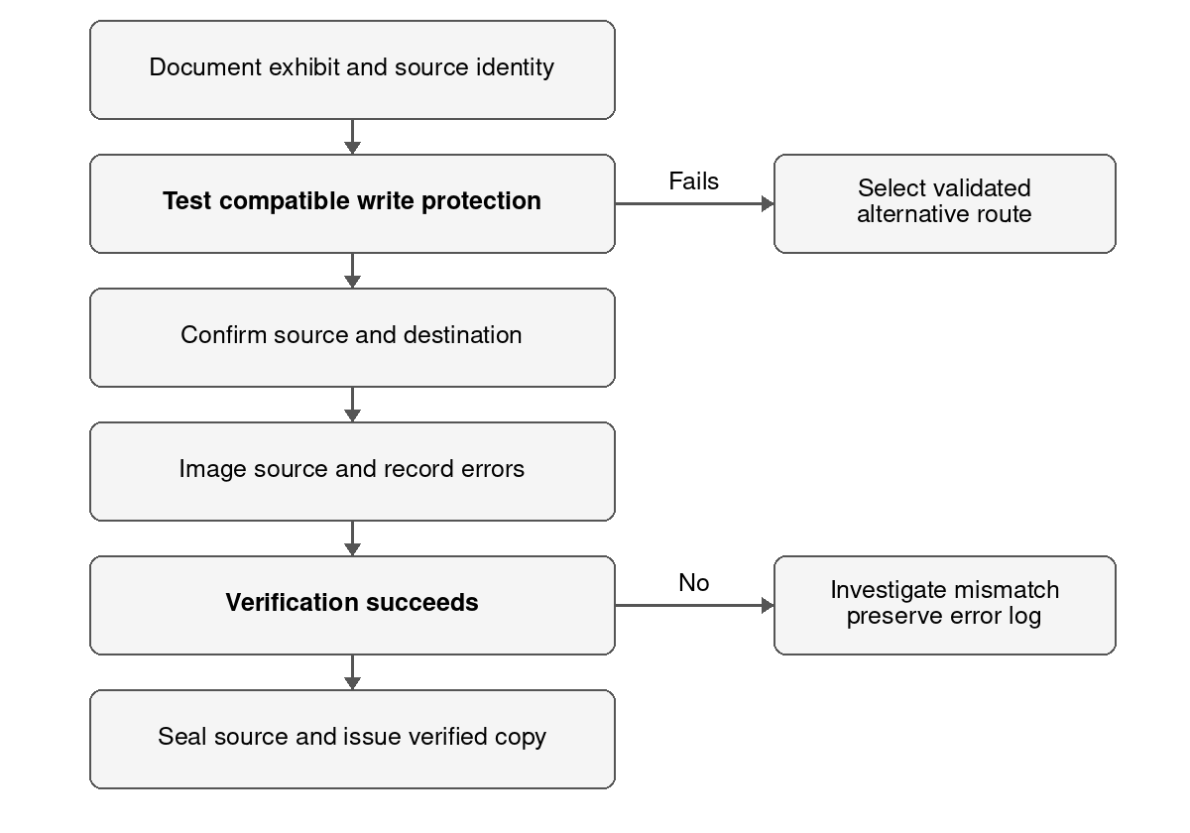
Figure 3 Proposed acquisition with source and integrity checks
Use IXImager only after the laboratory confirms support for the source interface, sector layout, image format, and selected build. A historical NIJ and NIST test report concerns IXimager version 2.0 from 2006 [R3]; its results cannot be extended automatically to a different build or modern NVMe hardware.

Imaging procedure and integrity verification
Identify each source by exhibit ID, model, serial number, capacity, and interface. Photograph and document any SSD removal with authority, handling steps, and seals. If the storage cannot be removed or the hardware is unsupported, select another authorized validated acquisition route and explain its limits. A forensic boot environment is not a substitute for tested write protection.
Test a compatible hardware write blocker on non-evidence media and record its model, firmware, and result. Attach the source through that blocker with automount prevented. Confirm source identity and capacity again inside the acquisition environment. Use a clean destination with adequate space; a second examiner or documented check should confirm source and destination are not reversed.
Configure a full addressable device acquisition in the supported IXImager build. Record case fields, byte range, image format, segmentation, compression if used, chosen digests, start and end times, and error policy. Acquire D1 and D2 separately. Preserve skipped or unreadable sector information, retries, substitution behavior, warnings, and every image segment. Do not repair the source file system to improve the result.
Verify the image through the tool's supported verification procedure and, where feasible, an independent reconstruction and hash check. Record digest algorithms explicitly. SHA-256 is the preferred reporting digest in this proposed workflow; if the selected older build computes only a legacy digest, retain it and compute SHA-256 independently over the same reconstructed byte scope where supported. A failed match requires explanation and a documented response, not a successful status label.

Comparing the correct byte sequences
Comparison | Proposed digest fields | Meaning if they match
Protected source stream and reconstructed image stream | H_source and H_image using the same algorithm and byte range | Acquired content corresponds to the bytes read from that defined source scope, subject to documented read errors.
Master image file and transferred copy | H_master_file and H_copy_file | The image or container file was transferred without byte changes.
Exported file before and after transfer | H_export_before and H_export_after | That derivative file remained unchanged during transfer.
Source stream before and after offline acquisition if a second read is justified | H_source_before and H_source_after | Supports stable readable source bytes over those reads.

These H labels are fields to be filled with actual outputs, not hash values. The compressed ASB container's file digest usually differs from the digest of its reconstructed source stream because metadata and encoding differ. Compare like with like. On failing media, repeated reads can worsen damage or produce different results; avoid unnecessary full rehashing and record the recovery strategy. SSD internal behavior also limits what host write protection can guarantee.

ASB evidence container and safekeeping
ASB is a proprietary forensic container used in the IXImager and ILook ecosystem. The published acquisition test includes segmented .asb output and acquisition logs [R3], and the author's publisher describes ASB as an evidence container [R4]. Its role is to hold acquired evidence in a format that the validated analysis build can reopen. Exact format capabilities should be verified against that build rather than inferred from the extension.
Whether information is embedded or stored as companion records, preserve the case and exhibit IDs, source identity, examiner, date and timezone, acquisition scope, tool version, image settings, segment manifest, read error map, hash algorithm and result, verification log, and custody history. Preserve all companion files needed to reconstruct the evidence. The container does not replace custody documentation or independent validation of important findings.
Keep the source media sealed after acquisition. Store the master image and logs in controlled evidence storage, restrict access by role, and maintain a verified backup under separate controls. Record opening, copying, transfer, and examination of evidence. Protect encryption recovery material separately from general reports; its access history should also be accountable.

Data carving and its limits
Data carving searches byte patterns and structural features to recover candidate objects without depending on complete directory or allocation metadata. It is useful when a partition or file system is damaged, directory entries are lost, or a deleted file's content remains in unallocated space. In this scenario it may help recover a deleted PDF design from the USB if its data blocks survive.
Carve only from a verified working image. Record tool and settings, input byte range, output offset, candidate type, size, and validation results. Check format structure and readable content before interpreting a candidate. Fragmentation, embedded files, false header matches, overwritten sectors, and missing footers may produce partial or misleading results. A carved file usually cannot be given its original filename, author, or creation time without separate metadata evidence. Ciphertext is not meaningfully carved into plaintext without authorized decryption.

Date and time problems
Retain original timestamp values and identify the source format. NTFS commonly stores UTC timestamps, while other file systems and applications may use local time, different resolutions, or format specific timezone fields. exFAT timestamps need their timezone and precision information interpreted rather than treated automatically as UTC. Copying can preserve modification time while changing creation time on the destination.
Compare device clock settings, historical synchronization records, and trusted server events when available. An observed clock offset at intake is not automatically valid for the entire incident period. State intervals and uncertainty for ambiguous times. Do not rewrite source timestamps; keep normalized timelines as derivatives with documented conversions.

Chain of custody form
The form below is an illustrative custody sequence, not a record of an actual seizure. Times use IST on 26 September 2026. Replace role labels with real names and obtain real signatures during an authorized collection. D2 requires its own custody form with the same level of detail.
Time | Exhibit and action | From and to | Seal and condition | Signatures
09:10 | D1 laptop collected at research office | Scene custodian to collecting officer | Powered off; photographed; label LT04 | [Both sign]
09:25 | D1 packaged for transport | Collecting officer retains custody | Illustrative seal S101; no visible damage | [Collector signs]
10:05 | D1 received in laboratory | Collecting officer to evidence custodian | S101 intact; intake checked against photographs | [Both sign]
10:30 | D1 released for documented SSD access | Evidence custodian to examiner | S101 opened with authorization; handling logged | [Both sign]
11:00 | SSD D1a registered and acquisition starts | Examiner retains custody | Illustrative SSD serial NVME-EX04; write blocker recorded | [Examiner signs]
13:10 | Acquisition and verification completed | Examiner retains custody | Actual digests and any errors must be recorded here | [Examiner signs]
13:30 | D1 and D1a returned to secure storage | Examiner to evidence custodian | Resealed S102 and S103; relationship retained | [Both sign]
14:00 | Verified working image issued for analysis | Evidence custodian to analyst | Copy manifest, digest and access permissions recorded | [Both sign]

For an internal SSD removed from D1, register D1a as a child exhibit and retain the parent relationship. The laptop chassis and removed SSD may need separate seals. Never record a disconnected SSD as still installed. The acquisition log should refer to D1a as the source, while the scene record describes D1.
The full form needs case number, authority reference, description, exact location, sender and recipient names, purpose, action timestamp and timezone, packaging condition, seal changes, signatures, and storage location. A separate digital movement log identifies every image, export, digest, and receiving system. Custody documents accompany the exhibits throughout analysis and return or disposal.

Conclusion and project outcome
The planned procedure preserves the powered off laptop and attached USB as separate exhibits, images their documented addressable storage through tested write protection, and separates source stream verification from container file verification. The expected outputs are two verified acquisitions, their logs and manifests, the custody forms, and protected working copies. Encryption, damaged sectors, SSD behavior, unsupported hardware, or missing metadata may limit recovery and must be stated. No conclusion about theft is justified from acquisition alone.

Mini project 4 Deleted evidence from shadow copies

Scenario and scope
Unique title: Reconstructing deletion of supplier bid records from a procurement workstation.
The fictional procurement office suspects that an employee copied a confidential bid comparison spreadsheet and later deleted the local spreadsheet and browser upload history. A verified image of Windows workstation PROC-PC12 is available. Its NTFS volume is assumed to contain shadow copies from before and during the suspected activity. The target file is BidComparison_Sept.xlsx. The question is whether earlier versions survive, what they contain, and which events can be reconstructed without overinterpreting timestamps.
Assumptions: the image includes the relevant snapshot metadata and associated data; the examiner has authorized access; snapshots are actually recoverable; and the suspected window is 27 September 2026, 09:00 to 11:30 IST. These are conditions to verify. The existence of the VSS service alone does not prove that any useful snapshot exists.

Selection and classification
Preserve the complete master image. Select evidence in a working view using authorized accounts, filenames, paths, supplier identifiers, time intervals, and relevant file types. Remove irrelevant data from the analysis view through reversible filters, not by deleting it from preserved evidence. Keep an exclusion record and revisit filtered items when new leads arise. Retain evidence of routine backups, approved uploads, or other explanations.
Category | Example in this scenario | Relevance and handling
User created files | Bid spreadsheet, drafts, exported PDF, supplier emails | Examine content and version differences; retain native formats and metadata.
System and application files | Registry hives, EVTX, browser databases, file system journal | Provide activity context; parse with documented settings.
Potentially suspicious files | Unusual archive, copied bid sheet, uploader configuration | Tag for review; suspicious status is a lead, not proof.
Deleted or recovered artifacts | Recycle Bin records, snapshot versions, carved fragments | Record recovery method, original location if known, snapshot ID, and completeness.
Supporting and contextual evidence | Audit policy, backup schedule, device clock records | Tests assumptions and alternative explanations.
Excluded from current review | Unrelated music files or system material outside the question | Retain in master evidence and log reversible exclusion rationale.

An item may belong to multiple categories. For example, a snapshot browser database is both an application record and recovered evidence. The classification scheme organizes review; it does not change the underlying source or predetermine the conclusion.

Event Analysis Cloud Analysis and Lead Analysis
Event Analysis organizes time related records so that an examiner can move from a broad activity period to the source records behind a cluster. ILookIX's documented event view can show file and email events [R4]. In this scenario, inspect the interval around creation of the bid sheet, the suspected upload, and later deletion. Verify each important event against its actual field meaning and source record rather than treating every plotted timestamp as a user action.
For this unit, Cloud Analysis is used in the course sense of a word or term cloud over indexed case text. This analytical assumption should be checked against the laboratory version. It helps prioritize terms such as a supplier name, bid code, or unusual project phrase. It does not mean acquiring Internet cloud services; that separate problem is addressed in mini project 5. A frequent word is a search lead, not evidence of wrongdoing.
Lead Analysis models relationships between case entities and indexed evidence. The publisher's author describes a link model that depends on indexing [R4]. Start with the bid code, spreadsheet path, account SID, recipient address, and upload domain. Each relationship must point back to an actual source record; manually drawn connections are investigator hypotheses until corroborated.
Analysis approach | Question it helps answer | What must be checked
Event Analysis | Which activity clusters occur near the suspected copy and deletion window? | Time fields, source clock, duplicates, and raw records.
Cloud Analysis under the stated assumption | Which recurring terms suggest relevant suppliers or documents? | Indexed scope, stop words, context, and unrelated repeated text.
Lead Analysis | Do records connect the bid code, account, document, and destination? | Provenance of every link and whether it is recorded or inferred.

Applying the approaches together
First categorize and index the authorized evidence. Use terms from the complaint and legitimate business context rather than only words that suggest guilt. Open search hits and read surrounding text. Event Analysis can then narrow the temporal window. Lead Analysis relates records found within and outside that window, including explanations such as scheduled backup jobs or authorized supplier exchanges.
For example, the term coating may appear in a supplier email, a spreadsheet cell, and a cached webpage. Its recurrence justifies examining the records. It does not establish that the webpage received the spreadsheet. A provider upload record, local transfer artifact, or another independently validated record would be needed for that inference.
The proposed output is a documented set of source linked leads, a time view, and a relationship matrix. Preserve search terms, index settings, filters, and records behind diagrams. Screenshots may illustrate a completed analysis only if genuinely produced; this report contains no simulated tool screenshots.

Volume Shadow Copy recovery workflow
VSS coordinates point in time copies of volume data [R5]. Earlier file content may therefore survive in a retained snapshot even when the current volume no longer contains the file. Availability depends on snapshot timing, intact storage and metadata, and retention. A snapshot cannot supply a file that was created and deleted entirely between snapshots if no snapshot captured it.
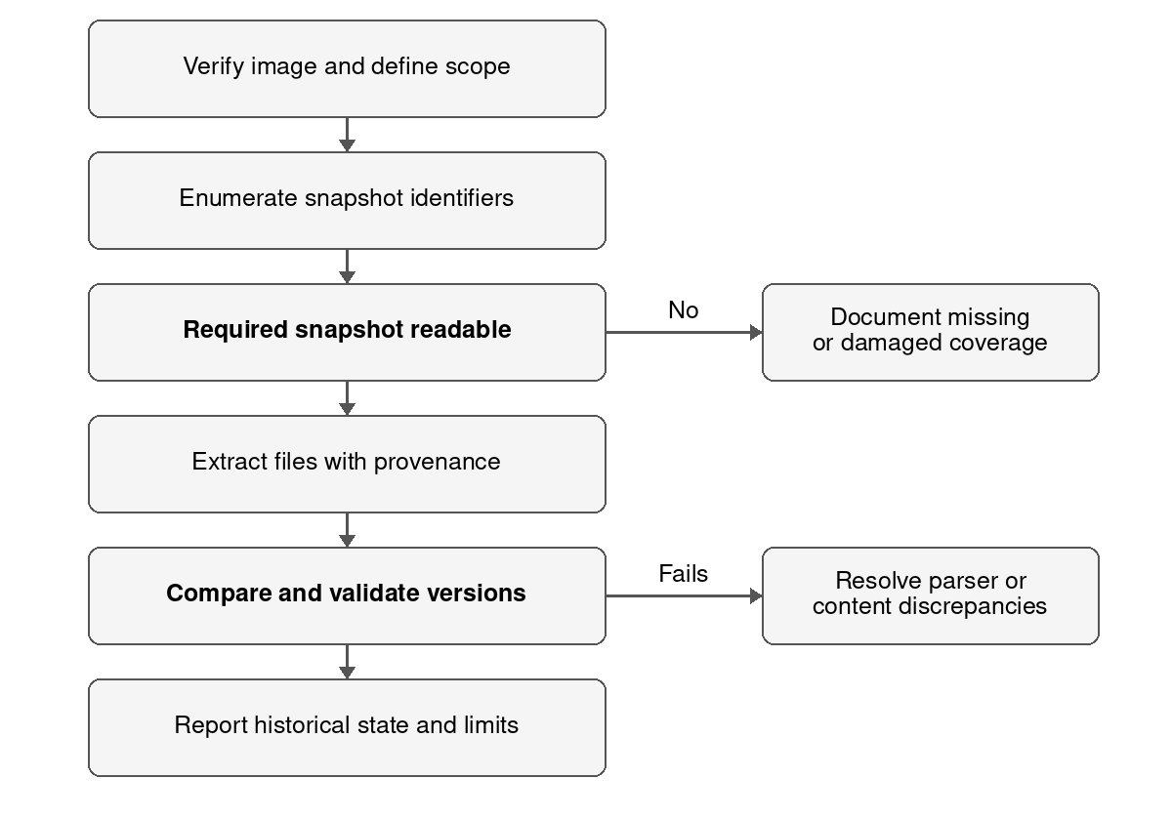
Figure 4 Proposed recovery and validation of snapshot evidence
Process a working image read only using a validated VSS capable tool. ILookIX Advanced is one proposed option; automatic snapshot processing is edition dependent [R2]. Do not create, delete, restore, or repair shadow copies on the original system to make examination easier. A live command that lists VSS copies is not an offline recovery of the preserved image.
For every recovered file, preserve the originating image, volume ID, snapshot ID, snapshot creation time, original path, extraction method, tool version, exported byte size, and digest. The extraction timestamp describes laboratory recovery, not original creation or deletion. Preserve incomplete extraction warnings and relevant transactional database companions.

Hypothetical event timeline
All events below are examples on 27 September 2026 in IST. Snapshot times describe captured states, not the exact moments when the user changed a file. An independent upload destination is not assumed proven merely because a browser row exists.
Time | Hypothetical event and source | Interpretation
09:00 | Snapshot VSS-A is created; target spreadsheet absent | Establishes an earlier captured state, subject to validated snapshot coverage.
09:12 | BidComparison_Sept.xlsx created; NTFS and application records | Consistent with local creation; filename and timestamp require context.
09:28 | Spreadsheet saved with revised supplier totals | Content in a later snapshot can establish that version, but may not reveal every intermediate edit.
09:35 | Snapshot VSS-B captures the revised spreadsheet | A recoverable historical version should contain the state present at this snapshot.
09:42 | A second file appears on removable volume | Consistent with copying if bytes match and the device association is verified; not proven by matching names.
09:46 | Browser visit to an upload page is recorded | Shows a database entry for the page; visit alone does not prove an upload completed.
10:00 | Snapshot VSS-C captures spreadsheet and browser database | Gives another point in time for comparison with VSS-B and the active volume.
10:08 | Target spreadsheet deleted; journal and Recycle Bin evidence if retained | Supports deletion at account or system level; determine whether routine cleanup explains it.
10:12 | Current browser database no longer contains the relevant row | Comparison supports a change; targeted deletion or intent requires further evidence.
28 September 14:20 | Examiner exports the file from VSS-B | Recovery time is a laboratory event; it must not be reported as file creation time.

Comparing versions and interpreting order
Compare VSS-B, VSS-C, and the active volume by path, file identity, content hash, and meaningful spreadsheet differences. A full file digest can change because a document package was resaved even if visible cell values are unchanged. Describe both byte level differences and substantive content differences. Record which cells changed rather than inferring fraud from a differing digest.
For a browser database, keep the original database and any available write ahead log or journal relevant to the snapshot. Use a parser that understands the schema, and validate critical rows against the preserved structure. A historical row that is absent now demonstrates a state difference; it does not alone show who removed it or why.
This example supports survival of an earlier bid spreadsheet and a later deletion sequence if the records are validated. It does not establish that the browser uploaded the spreadsheet, that deletion was deliberate concealment, or that the employee was the operator. The available evidence should bound these questions instead of filling gaps with assumptions.

Validation checklist
Validation check | Required evidence or action
Input identity | Verify the working image against the acquisition manifest and retain the original verification record.
Snapshot identity | Record volume and snapshot identifiers, creation time, reconstruction method, and any missing components.
Extraction provenance | Preserve original path, tool build, settings, export time, byte size, and snapshot association.
Byte integrity | Hash the export and any transferred copy using the same algorithm; retain actual values.
File structure | Confirm the recovered format is internally consistent and record damaged or missing parts.
Content plausibility | Inspect native document structure and meaningful content without altering the master export.
Independent validation | Reconstruct or parse a critical artifact with a second method where feasible; explain discrepancies.
Corroboration | Compare current and snapshot file records, application records, and independent events.
Reporting | Separate observed state differences from inferred user actions and disclose unresolved alternatives.

The checklist is a proposed gate, not a set of completed results. A future laboratory log should mark each item complete, failed, or not applicable with a reason and supporting exhibit. A recovered file's matching transfer hash proves stability of the exported bytes; it does not prove that snapshot reconstruction was correct or that the file's statements are true.

Errors and alternative explanations
Clock drift, timezone conversion errors, low timestamp resolution, and copied modification times can distort apparent order. An application may save a temporary file and rename it, making file system events look like manual creation and deletion. Browser synchronization, normal retention, privacy settings, database maintenance, or antivirus cleanup may remove records automatically. A Recycle Bin record may not exist for permanent deletion, network shares, or particular cleanup methods.
Snapshot retention can erase earlier states, and damaged differential storage may prevent complete reconstruction. Duplicate files in several snapshots are multiple captured states rather than independent witnesses. Carved records may lack their original path or relational context. Parser errors and document metadata written by templates can mislead attribution. No conclusion should depend solely on a missing artifact or an unvalidated timestamp.
Test alternatives through application settings, tasks, cleanup records, audit configuration, and snapshot coverage. Record why each explanation is supported, weakened, or unresolved. Investigate conflicting times rather than averaging them.

Conclusion and project outcome
The project supplies classification, three analysis approaches, the recovery flowchart, timeline, and validation criteria. Validated snapshots can establish historical content and changes. Human responsibility, concealment, and external disclosure require additional evidence.

Mini project 5 Multi source cyber investigation

Scenario and objectives
Unique title: Suspected phishing and session misuse of a student robotics service account.
The fictional student account robotics.s24 is associated with an unauthorized download of private robot design files from the college's online collaboration service. Available sources are a Windows laptop, browser profile, institutional email, a class messaging conversation, an Android phone, and authorized provider records. The student reports receiving a verification message before the incident and denies downloading the files. The investigation must test both deliberate account misuse and account compromise.
Assumptions: collection authority explicitly identifies the service tenant, account, devices, relevant correspondence, and date window; provider audit logs are retained; laptop and phone belong to the consenting student or are otherwise lawfully examinable; and the incident window is 29 September 2026, 18:00 to 19:30 IST. This does not authorize access to every private conversation or every cloud account on either device.
Objectives are to reconstruct the message and login sequence, identify which session performed the service request, assess whether content reached a local device, and determine where attribution remains uncertain. Stable tenant, account, event, session, message, and device identifiers should be preferred over display names or approximate IP geolocation.

Multi source evidence map
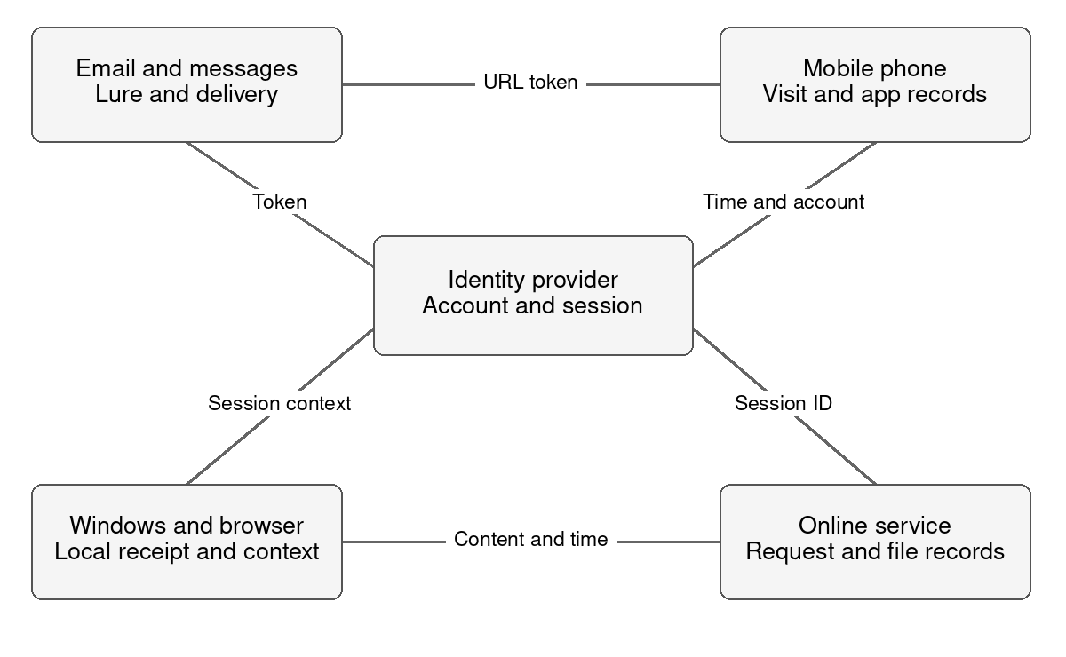
Figure 5 Proposed correlation map with independent evidence paths
The map describes sources to be examined. Connections are questions to test, not completed findings. The service session is the correlation point for provider activity, while messages and device artifacts test how that session may have been obtained and used.

Computer browser email and messaging evidence
Source | Potential artifacts | Investigative question and limit
Windows laptop | Security EVTX, user profiles, registry, NTFS metadata, USN journal, shortcuts, recent files, and sync records | Which account context and local files were active? Availability depends on settings and retention.
Linux system if relevant | Authentication logs, journal records, home directories, browser profiles, shell history, and ext4 metadata | Was another OS or device involved? History may be disabled, edited, or absent.
macOS system if relevant | User directories, APFS structures, unified logs, browser records, and authorized keychain context | Is there cross device activity? Support and retention must be assessed for that version.
Browser | History, downloads, cached pages, cookies, extension data, and session records | Is there evidence of the verification page, service use, or file download? Sync and background requests can create entries.
Email | Native message, MIME parts, transport headers, message ID, attachment bytes, and server delivery logs | When and how did the lure arrive? A From display name is not a verified sender identity.
Messaging | Relevant thread, platform account IDs, message IDs, attachments, edits, delivery times, and database records | Was the lure forwarded or discussed? Screenshots can omit context and lack reliable provenance.

Browser history can reveal stored URLs and visit times, while a download record may describe a target path, source, start, and completion status depending on the schema. Neither a page title nor a cached object alone demonstrates deliberate browsing or successful data theft. Prefetching, redirects, extensions, synchronization, and another user of the profile can produce activity. A missing history row may result from private browsing or cleanup rather than no activity.
Collect browser databases with available companion files from preserved evidence. Do not use recovered cookies or tokens to log into the service as the student. Treat authentication material as sensitive evidence. A live provider acquisition should use a separately authorized administrative export path with its own log.
For email, retain native content and full headers rather than only a screenshot or printed page. Correlate server accepted delivery time with message ID, recipient, lure URL, and an attachment digest if present. Authentication results require trusted receiving server context; forwarded messages and spoofed headers need caution. For messaging, preserve the relevant surrounding conversation and stable account IDs without collecting unrelated discussions unnecessarily.
The lure email and forwarded message may share a distinctive URL token. Matching that token to a browser record is stronger than matching only a common domain. Do not reproduce live secrets or private attachment contents in the public report; use redacted exhibits that remain traceable to preserved originals.

Mobile examination and Internet cloud records
The Android phone may contain a relevant message, email application data, browser records, notification remnants, downloaded files, account metadata, and authorized backup data. The acquisition route depends on model, OS build, security patch, lock state, encryption, application versions, and validated tool support. A physical extraction is not guaranteed and may be neither available nor necessary. Preservation and acquisition choices must be documented [R6].
At collection, photograph the device and record power, lock state, displayed time, identifiers, network state, and battery condition. A trained examiner chooses network isolation and power management based on the device state and remote change risk. Airplane mode changes settings and may not disable all radios; a shielding enclosure requires verified effectiveness and a battery plan. Do not assume a powered on unlocked phone should be switched off, because a reboot can change access to encrypted data.
Prefer the least intrusive authorized extraction that answers the questions. Record whether it is a logical export, backup, application extraction, or fuller file system acquisition, and what it omits. Document every interaction, tool version, extraction time, errors, and changes introduced. Never use an ordinary messaging interface to forward evidence to the examiner's private account. For end to end encrypted services, a provider may have metadata but no recoverable plaintext; device access and retention still matter.

Relevant remote sources
Source | Authorized records requested | Purpose and limit
Collaboration service | Audit events, file and version IDs, download result, tenant and account IDs | Connects the service action to an authenticated session; account ownership is not proof of operator identity.
Identity provider | Sign in attempts, authentication outcome, session IDs, device or client data, and MFA records | Tests how the session was obtained; a successful MFA event does not rule out session compromise.
Institutional email server | Delivery trace, native lure message, and trusted header context | Validates arrival and route of the verification message.
Campus network | Time bounded DHCP, NAT, proxy, DNS, and firewall records where retained | Maps local network context; a shared public IP does not uniquely identify a device or person.
Messaging or storage provider | Relevant thread export, object metadata, audit events, retention and export details | Supplies remote corroboration; availability depends on authorization and provider design.

Send preservation requests promptly through authorized channels, then collect the scoped records. Preserve native exports, the query and filters, account and tenant scope, provider timezone, collection timestamp, event pagination, request or job ID, coverage limits, and digests of received files. A received file's hash protects it after receipt; it cannot independently establish completeness of the provider's export.
Avoid uploading the student's evidence to public analysis services. Preserve provider custody and export descriptions alongside local records. Service content, identity provider data, and laptop artifacts are separate evidence sources even if one product presents them in a single dashboard.

Cross source correlation matrix
The following seven artifacts are hypothetical, not collected findings. Time values refer to 29 September 2026 in IST. RQ44 and S77 are illustrative request and session labels; they are not real identifiers. Stable linking fields should be retained in the native export.
ID and source | Example time and artifact | Correlation and bounded inference
M1 Email server | 18:02 lure delivered to robotics.s24 with token VERIFY-K9 | Establishes recorded delivery; receiving an email does not show the student clicked it.
M2 Messaging record | 18:04 forwarded lure with the same token | Links the conversation to the lure; sender account and forwarding context need validation.
M3 Phone browser | 18:06 history row for the lure URL and token | Corroborates recorded exposure on the phone; history alone does not prove credential entry.
M4 Identity provider | 18:10 successful sign in and session S77 from unfamiliar client | Direct record of authentication; unfamiliar client does not alone prove an attacker.
M5 Service audit | 18:14 successful design file download RQ44 under session S77 | Direct record of the service action if schema and outcome are validated; downloaded content and actor remain separate questions.
M6 Laptop browser | 18:14:07 download record with design filename and destination | Corroborates a local download entry; connect to RQ44 only if a shared identifier is actually retained.
M7 Laptop filesystem | 18:14:10 design archive at that destination, matching provider reference bytes | Supports local content receipt if verified; does not identify who operated the laptop.

M4 and M5 can be directly joined by S77 if the provider's documented schema permits that relationship. M6 may not retain the service request ID. In that case, compare URL, authenticated account context, content ID, destination, completion status, and a bounded time interval, and describe the join as an inference. Common time and filename are not enough for an exact session match.
M1 to M3 link through the distinctive lure token. If that token could be forwarded widely or rewritten by a security gateway, its value changes. Compare the native email URL, actual browser URL, and gateway rewrite records where available. Neither a token nor an IP address uniquely identifies a human.

Reconstructed sequence and competing hypotheses
The examples form a plausible sequence: lure delivery, message forwarding, recorded phone visit, new authenticated session, service download, and local laptop file arrival. Normalize provider UTC and local artifacts independently and preserve clock error bounds. For example, 12:44:00Z equals 18:14:00 IST before any supported clock correction.
Hypothesis one is deliberate download by the student. Hypothesis two is stolen credentials or a session used by another operator. Hypothesis three is legitimate background synchronization or approved access misclassified as unauthorized. Test them with actual service permissions, session history, client identity, local account activity, endpoint compromise evidence, and approved robotics tasks. The illustrative phone visit is compatible with compromise but does not prove it. The laptop file is compatible with local receipt but does not prove intent.

Challenges with distributed evidence
Challenge | Effect on this case | Proposed response
Authority and jurisdiction | Device consent may not cover provider data or another participant's messages | Define account, tenant, dates, and lawful scope; use authorized provider channels.
Provider control and multitenancy | Full server imaging could expose other customers and is usually unavailable | Request scoped audit and content exports with provenance.
Retention and volatility | Sessions, logs, notifications, or temporary files may disappear | Prioritize preservation and document coverage gaps.
Encryption and lock state | Phone or application content may be inaccessible | Preserve state and use supported authorized acquisition; report inaccessible data.
Clock and timestamp differences | Events may appear out of order across services | Retain raw fields and normalize with measured or justified uncertainty.
Identity and shared infrastructure | Account, IP, device, and human identity may diverge | Join stable identifiers and seek independent corroboration.
Tool and schema changes | A parser may misread a new database or export field | Validate critical records and retain original exports and tool versions.
Volume duplication and privacy | Synced copies can inflate evidence counts and expose unrelated data | Deduplicate the working view while retaining provenance and scoped originals.
Export completeness | Filters, API pagination, or provider limits may omit records | Preserve queries and page counts; check stated limits and returned coverage.

These case specific controls address the broader problem of cloud forensics described by NISTIR 8006 [R10]. No single source should be treated as complete merely because it produces a large export. A lack of provider records may mean nonretention rather than that the incident never occurred.

Final investigative summary
Direct example evidence consists of native provider authentication and service action records, plus records documenting local database entries and file presence. These establish narrow technical events if validated. Corroborating evidence consists of the lure token across email, messaging, and phone records, and consistent laptop download and file artifacts. Time, client labels, and network location are useful context with distinct uncertainty.
Unresolved questions include who controlled session S77, whether the reported permission breach was real, whether credentials or a session were stolen, whether the laptop file arrived through the audited download or synchronization, and whether any further redistribution occurred. The final report must not convert a student owned account into proof that the student personally acted.
On the hypothetical pattern, account use and possible local receipt are supported, while the compromise mechanism and human attribution remain open. Preserve records before authorized session revocation or other containment, record any urgent changes, and request the missing session and endpoint evidence. The project provides a multi source map, correlation matrix, challenge analysis, and a conclusion separating direct records, corroboration, and unresolved issues.

References
References support the technical principles and tool descriptions. The scenarios, timelines, evidence matrices, and proposed procedures are applications developed for these five academic cases. Technical sources were consulted on 5 October 2026. Tool features and legal application must be checked for the actual laboratory and proceeding.
[A] Rajalakshmi Engineering College. CR23532 Cyber and Digital Forensics Case Study Assignments II. Provided file CR23532_CDF_second assignment.docx. Used for the five questions and submission requirements; a separate full syllabus was not supplied.
[R1] Kent K, Chevalier S, Grance T, Dang H. Guide to Integrating Forensic Techniques into Incident Response. NIST SP 800-86. 2006. General process and preservation guidance.
URL: https://csrc.nist.gov/pubs/sp/800/86/final
[R2] XtremeForensics. ILOOKix Digital Forensics Toolkit. Vendor description of editions and supported analysis functions. Version and hardware compatibility require laboratory verification.
URL: https://xtremeforensics.com/ilookix.html
[R3] National Institute of Justice and NIST. Test Results for Digital Data Acquisition Tool IXimager Version 2.0 Feb 01 2006. NCJ 217678. April 2007. Historical build specific acquisition testing and example ASB output.
URL: https://ojp.gov/pdffiles1/nij/217678.pdf
[R4] Boddington R. Selecting and Analyzing Digital Evidence. Packt. 8 April 2016. Author's discussion of ILookIX categorization, indexing, event and lead models, and ASB evidence containers. Historical tool discussion is used cautiously.
URL: https://www.packtpub.com/en-us/learning/how-to-tutorials/selecting-and-analyzing-digital-evidence
[R5] Microsoft. Volume Shadow Copy Service VSS. Microsoft Learn. Describes point in time volume copies and VSS architecture.
URL: https://learn.microsoft.com/en-us/windows-server/storage/file-server/volume-shadow-copy-service
[R6] Ayers R, Brothers S, Jansen W. Guidelines on Mobile Device Forensics. NIST SP 800-101 Revision 1. 2014. General preservation and acquisition guidance; device specific support must be verified.
URL: https://csrc.nist.gov/pubs/sp/800/101/r1/final
[R7] Government of India. The Bharatiya Sakshya Adhiniyam 2023. Act No 47 of 2023. Sections 61 to 63 and Schedule. Official text.
URL: https://www.mha.gov.in/sites/default/files/2024-04/250882_english_01042024_0.pdf
[R8] Microsoft. Event 4624 An account was successfully logged on. Microsoft Learn. Used for account and session interpretation.
URL: https://learn.microsoft.com/windows/security/threat-protection/auditing/event-4624
[R9] Microsoft. Event 4663 An attempt was made to access an object. Microsoft Learn. Used for audited object access interpretation.
URL: https://learn.microsoft.com/en-us/previous-versions/windows/it-pro/windows-10/security/threat-protection/auditing/event-4663
[R10] Herman M and colleagues. NIST Cloud Computing Forensic Science Challenges. NISTIR 8006. 2020. Distributed evidence and cloud investigation challenges.
URL: https://csrc.nist.gov/pubs/ir/8006/final

